ACHARYA INSTITUTE OF GRADUATE STUDIES
(AFFILIATED TO BANGALORE UNIVERSITY)



PROJECT DOCUMENTATION ON

FATE –ACADEMIC TIMELINE SIMLUATOR

SUBMITTED BY
KEERTHANA G
DARSHAN
SAWRAJ

FATE –ACADEMIC TIMELINE SIMLUATOR

INDEX
Chapter No. Title

- Introduction
- Objectives of project
- Scope of the Project
- Feasibility Study
- System Design
- Existing application
- Proposed application
- ER Diagram
- Screenshots of database
- Coding and your application screenshots
- Conclusion

ABSTRACT

In today’s rapidly evolving academic and career landscape, students often face confusion while choosing the right academic path and career direction. Many decisions are made without proper guidance, leading to dissatisfaction and lack of clarity about future opportunities. To address this issue, this project titled “FATE – Academic Timeline Simulator” has been developed.
FATE is a Java-based console application designed to assist students in making informed academic and career decisions. The system allows users to register and log in securely, create and manage their academic profile, and receive career suggestions based on their degree, CGPA, and areas of interest. The application provides a career decision module that analyzes student data and recommends suitable career paths.
An important feature of the system is the Academic Timeline Module, which displays both the current academic path and an alternate academic path, helping students understand possible future outcomes. Additionally, the What-If Scenario Simulation enables users to explore alternative career interests without modifying their original profile. The Career Outcome Module presents the final recommended role along with a preparation plan, while the Skill Recommendation Module suggests relevant skills required to achieve the chosen career.
The FATE system is modular, user-friendly, and designed using object-oriented principles. It helps students gain clarity about their academic journey and career planning. This project demonstrates how simple rule-based logic and structured programming can be effectively used to build decision-support systems in education.

INTRODUCTION

In the modern academic environment, students face increasing challenges when planning their educational and professional future. With a wide range of career options, emerging technologies, competitive job markets, and higher education opportunities, students often struggle to make informed decisions about their academic path. Traditional guidance methods such as manual counseling sessions or generic career advice are often limited, inconsistent, and not personalized according to individual academic performance and interests.
Students today are required to evaluate multiple factors such as degree specialization, CGPA, skill development, career interests, and market demand. However, there is no structured system that allows them to simulate how their current academic performance may influence their future career outcomes. As a result, many students experience:
• Confusion in choosing career paths
• Lack of clarity about higher education options
• Poor alignment between interests and academic decisions
• Uncertainty about skill requirements
• Inability to visualize long-term academic progression
This gap highlights the need for a structured academic simulation system that can analyze student data and provide meaningful guidance.
To address these challenges, FATE – Academic Timeline Simulator is proposed as a structured academic planning and simulation framework. The system is designed to analyze student information such as degree, CGPA, and area of interest, and generate suitable academic paths, career outcomes, timeline suggestions, and skill recommendations.
The application provides a centralized platform where students can:
• Register and securely manage their profile
• Input academic details
• Receive career decision suggestions
• View academic timeline simulations
• Explore alternate paths using What-If scenarios
• Obtain skill recommendations based on career goals
The system is developed using Java and follows Object-Oriented Programming principles. It implements the DAO (Data Access Object) pattern to ensure clean separation between application logic and database operations. MySQL is used as the backend database to securely store and manage student information, while JDBC ensures seamless connectivity between the application and the database.
FATE serves as both a technical implementation of backend development concepts and a practical solution to a real-world academic planning problem. By combining structured data analysis with academic guidance, the system enhances decision-making clarity and helps students better understand their potential future outcomes.

OBJECTIVE OF THE PROJECT:

1. Primary Objective
The primary objective of FATE – Academic Timeline Simulator is to design and develop a structured academic planning system that helps students analyze their academic performance and simulate potential career outcomes based on their degree, CGPA, and interests.
The system aims to move beyond traditional generic career advice by introducing a personalized academic simulation framework. Instead of providing one-time suggestions, the system evaluates academic inputs and generates structured career paths, timeline projections, and skill recommendations to help students make informed decisions about their future.

2. Secondary Objectives
2.1 To Analyze Student Academic Profile
One of the key objectives of this project is to analyze a student’s academic details such as:
• Degree qualification
• CGPA (academic performance)
• Area of interest
The system processes this information to understand the student’s academic standing and generates relevant career suggestions based on logical decision rules.

2.2 To Provide Career Path Suggestions
The project aims to recommend suitable academic and professional paths based on the student’s profile.
The system evaluates:
• Academic performance level
• Career interest domain
• Skill alignment
Based on these parameters, it suggests:
• Higher education options
• Professional roles
• Alternate career directions
This helps students gain clarity regarding possible future opportunities.

2.3 To Simulate Academic Timeline Progression
Another important objective is to simulate how a student can progress academically over time.
The system provides:
• Suggested next academic steps
• Alternate academic paths
• Structured progression guidance
This enables students to visualize their long-term academic journey instead of making short-term decisions without planning.

2.4 To Implement What-If Scenario Analysis
The project introduces a What-If simulation module that allows students to change their area of interest and observe how career outcomes vary.
For example:
• Switching from Data Science to Web Development
• Changing specialization interests
• Exploring alternate career domains
This objective enhances decision-making flexibility and helps students compare different career options before making final decisions.

2.5 To Provide Skill Recommendations
The system aims to recommend essential skills required for selected career paths.
It suggests:
• Technical skills
• Domain-specific knowledge
• Practical learning areas
This ensures that students not only choose a career path but also understand what skills they must develop to achieve it.

2.6 To Implement Structured Database Management
Another objective of the project is to implement proper database connectivity using MySQL.
The system:
• Stores user data securely
• Manages academic records
• Retrieves and updates information efficiently
This demonstrates practical implementation of backend development and database integration using JDBC and DAO pattern.

2.7 To Apply Object-Oriented and Backend Development Concepts
The project aims to demonstrate the application of:
• Object-Oriented Programming (OOP) principles
• DAO (Data Access Object) design pattern
• Modular programming
• JDBC connectivity
This ensures that the project is technically structured, maintainable, and scalable.

SCOPE OF THE PROJECT:

1. Introduction to Project Scope
The scope of FATE – Academic Timeline Simulator defines the boundaries, functionalities, and limitations of the system. It explains what the project includes, how it operates within an academic context, and what features are intentionally kept outside its current implementation.
This project is designed to function as an academic planning and career guidance support system. It focuses on analyzing student academic data and generating structured career suggestions, timeline simulations, and skill recommendations using rule-based logic and database integration.
The system acts as a decision-support tool and does not replace professional academic counseling.

2. Functional Scope
2.1 Student Data Collection and Management
The project includes the ability to collect and manage essential student academic data such as:
• User registration details
• Degree qualification
• CGPA
• Area of interest
• Career preference inputs
All data is stored securely in a MySQL database using structured tables and managed through the DAO pattern.

2.2 Academic Profile Analysis
Within its scope, the system analyzes:
• Academic performance (CGPA level)
• Degree specialization
• Interest domain
• Logical rule-based career mapping
The system processes these inputs to generate relevant academic and professional suggestions.

2.3 Career Decision Generation
The project provides structured career recommendations based on predefined decision logic.
It includes:
• Suggested higher education options
• Professional role recommendations
• Alternate academic directions
The recommendations are based on academic input values and interest categories.

2.4 Academic Timeline Simulation
One of the core scopes of the project is academic timeline simulation.
The system generates:
• Step-by-step academic progression guidance
• Alternate learning paths
• Career progression overview
This enables students to visualize how their academic decisions can influence their long-term career outcomes.

2.5 What-If Scenario Simulation
The system allows students to explore alternate possibilities by modifying their area of interest.
For example:
• Changing interest from Data Science to Web Development
• Exploring different career domains
• Comparing alternative outcomes
This feature supports flexible decision-making and career exploration.

2.6 Skill Recommendation Module
The project includes a module that provides recommended skills based on the selected or suggested career path.
It suggests:
• Technical skills
• Domain-specific tools
• Learning focus areas
This ensures that students understand what competencies are required to achieve their desired career.

3. User-Based Scope
3.1 Students
Students can:
• Register and log in
• Create and manage their academic profile
• View career suggestions
• Simulate academic timelines
• Explore alternate career paths
• Receive skill recommendations
The system is primarily designed for student users.

3.2 Academic Institutions (Indirect Scope)
Educational institutions may use this system as:
• A supplementary academic guidance tool
• A student career planning assistant
• A demonstration of backend academic system implementation
However, institutional dashboard-level analytics are outside the current scope.

4. Technical Scope
4.1 System Architecture
The project includes:
• Modular Java-based backend design
• Object-Oriented Programming implementation
• DAO (Data Access Object) pattern
• MySQL database integration
• JDBC connectivity
The architecture ensures separation of concerns and maintainable code structure.

4.2 Database Integration
The system supports:
• Structured data storage
• CRUD operations (Create, Read, Update, Delete)
• Secure database connectivity
It uses MySQL for persistent data management.

4.3 Rule-Based Decision Logic
The project uses:
• Predefined logical rules
• Conditional decision-making
• Structured output generation
Advanced AI or machine learning algorithms are outside the current implementation scope but may be added in future versions.

5. Security and Ethical Scope
The system ensures:
• Secure user login
• Controlled access to personal data
• No misuse of academic information
• Data confidentiality within the database
The project is designed purely for academic guidance and not for data exploitation.

6. Operational Scope
6.1 Educational Environments Covered
The project can be applied in:
• Colleges
• Universities
• Academic training institutions
• Student guidance programs
It is suitable for degree-level academic environments.

6.2 Academic Domains Supported
The system currently supports:
• General degree programs (e.g., BCA, BSc, BCom)
• Technology-related career paths
• Skill-oriented academic planning
Highly specialized professional domains (e.g., medical licensing systems, legal certifications) are outside the current scope.

7. Limitations and Exclusions (Out of Scope)
The following are outside the scope of this project:
• AI-based predictive analytics
• Real-time job market data integration
• Direct recruitment system integration
• Automated academic counseling replacement
• Web-based or mobile application interface
The current version is console-based and rule-driven.

8. Scalability and Future Expansion Scope
Although not part of the current implementation, the system supports future expansion such as:
• Web-based deployment
• AI-driven career prediction
• Graphical dashboard interface
• Real-time job market integration
• Admin control panel
• Cloud database hosting

9. Summary of Project Scope
In summary, the scope of FATE – Academic Timeline Simulator includes:
• Academic profile management
• Career decision generation
• Timeline simulation
• Skill recommendation
• What-If scenario analysis
• Secure MySQL database integration
• Structured backend architecture
The project provides a practical, student-focused academic guidance system that supports informed decision-making while demonstrating strong backend development concepts.

FEASIBILITY STUDY OF THE PROJECT:

1. Introduction to Feasibility Study
A feasibility study is conducted to determine whether FATE – Academic Timeline Simulator can be successfully designed, developed, implemented, and operated within available time, cost, technical resources, and academic constraints.
This study evaluates the project from multiple perspectives to ensure that it is:
• Technically implementable
• Economically affordable
• Operationally practical
• Schedule-friendly
• Ethically appropriate for academic use
The analysis confirms whether the project is suitable for real-world academic environments.

2. Technical Feasibility
2.1 Availability of Technology
The project is technically feasible because it is built using widely available and well-established technologies, including:
• Java programming language
• MySQL relational database
• JDBC for database connectivity
• DAO (Data Access Object) design pattern
• Standard development environment (VS Code)
All these technologies are stable, well-documented, and supported by large developer communities.

2.2 System Complexity
The system follows a modular and layered architecture that includes:
• Model classes
• DAO classes
• Menu-driven Main class
This structure:
• Reduces development complexity
• Allows independent module testing
• Supports easy debugging and maintenance
The decision-making logic is rule-based and does not require complex AI algorithms, making implementation manageable within an academic project timeline.

2.3 Database Integration Feasibility
The project uses MySQL for structured data storage.
It supports:
• User data storage
• Academic profile management
• Career suggestion retrieval
• CRUD operations
JDBC ensures smooth connectivity between Java and MySQL, making database integration technically feasible.

2.4 Performance and Scalability
The system:
• Handles student records efficiently
• Performs rule-based decision processing quickly
• Supports structured data expansion
Although currently console-based, the architecture supports future upgrades such as web-based deployment and scalable database hosting.

3. Economic Feasibility
3.1 Development Cost
The project is economically feasible because:
• It uses open-source technologies (Java & MySQL)
• No licensing cost is required
• Development tools are freely available
This makes it cost-effective and suitable for academic institutions.

3.2 Operational Cost
Operational costs are minimal because:
• It can run on standard computers
• No specialized hardware is required
• Maintenance requirements are low
The system can be deployed on institutional systems without additional infrastructure expenses.

3.3 Cost-Benefit Analysis
The benefits outweigh the development cost because the system:
• Provides structured academic guidance
• Reduces confusion in career planning
• Enhances student decision-making clarity
• Demonstrates practical backend implementation
Thus, the return on academic and educational value is significant.

4. Operational Feasibility
4.1 User Acceptance
The system is designed to be:
• Simple
• User-friendly
• Menu-driven
• Easy to understand
Students can easily interact with the application without requiring technical knowledge.

4.2 Training Requirements
Minimal training is required because:
• The interface is console-based
• Menu options are clearly structured
• Outputs are easy to interpret
Users can operate the system with basic instructions.

4.3 Workflow Compatibility
The system complements academic planning processes rather than replacing professional counseling. It serves as a decision-support tool, making it easy to integrate into existing academic workflows.

5. Schedule Feasibility
5.1 Development Timeline
The project can be completed within a standard academic semester timeline due to:
• Clearly defined modules
• Incremental development approach
• Modular architecture
Each module (User, Profile, Decision, Timeline, Skill Recommendation) can be implemented independently.

5.2 Risk Management
Potential risks such as:
• Database connectivity errors
• Invalid user inputs
• Logical decision mismatches
Can be managed through:
• Exception handling
• Input validation
• Testing and debugging

6. Legal and Ethical Feasibility
6.1 Data Privacy
The project ensures:
• Secure user login
• Confidential storage of academic data
• Controlled access to information
Student data is stored in MySQL and not shared externally.

6.2 Ethical Considerations
The system:
• Does not enforce decisions
• Does not replace academic advisors
• Provides suggestions, not mandatory outcomes
It acts as a supportive academic tool rather than an authoritative system.

7. Social Feasibility
The project promotes:
• Better academic awareness
• Career planning clarity
• Structured decision-making
It helps students become more confident and informed about their academic future.

8. Resource Feasibility
8.1 Human Resources
The project can be developed by:
• A single student developer
• A small academic team
• Faculty-guided supervision
No large technical team is required.

8.2 Hardware and Software Resources
Required resources include:
• A personal computer or laptop
• Java Development Kit (JDK)
• MySQL Server
• VS Code or similar IDE
All resources are readily available in academic environments.

9. Feasibility Conclusion
Based on the technical, economic, operational, and ethical analysis, FATE – Academic Timeline Simulator is highly feasible for implementation in academic institutions.
The project:
• Uses proven technologies
• Requires minimal cost
• Is easy to operate
• Aligns with educational objectives
• Supports future expansion

10. Summary
The feasibility study confirms that the project is:
• Technically implementable
• Economically affordable
• Operationally practical
• Academically beneficial
• Scalable for future enhancements
Thus, FATE – Academic Timeline Simulator is a viable and sustainable academic planning solution suitable for student guidance systems.

SYSTEM DESIGN

1. Introduction to System Design
System Design defines how the proposed system works internally. It explains the overall architecture, components, modules, data flow, and interaction between different parts of the system.
For FATE – Academic Timeline Simulator, the system is designed as a modular, structured, and database-driven academic decision-support system that helps students plan their academic journey and career path based on their profile and performance inputs.
The design focuses on:
• Simplicity
• Structured data management
• Modular implementation
• Easy maintenance
• Future scalability

2. Overall System Architecture
The system follows a Layered / Modular Architecture, ensuring separation of concerns and organized implementation.
Architecture Type
Layered Architecture (Console-Based Application)
Major Layers
- Presentation Layer
- Application (Business Logic) Layer
- Decision & Recommendation Engine Layer
- Data Management Layer
- Security & Validation Layer

3. High-Level Architecture Diagram (Conceptual)
┌──────────────────────────┐
│ Presentation Layer │
│ (Console Interface) │
└───────────▲─────────────┘
│
┌───────────┴─────────────┐
│ Application Logic Layer│
│ (Workflow & Validation)│
└───────────▲─────────────┘
│
┌───────────┴─────────────┐
│ Decision & Recommendation│
│ Engine │
└───────────▲─────────────┘
│
┌───────────┴─────────────┐
│ Data Management │
│ (MySQL Database) │
└───────────▲─────────────┘
│
┌───────────┴─────────────┐
│ Security & Validation │
│ (Authentication, Checks)│
└──────────────────────────┘

4. Module-Wise System Design

1. Presentation Layer (User Interface Module)
Purpose
Provides interaction between the user and the system.
Users
• Students
• Academic users
Functions
• User registration
• Login authentication
• Menu display
• Academic data input
• Career suggestions display
• Timeline generation
Characteristics
• Console-based interface
• Menu-driven navigation
• Simple and easy-to-use
• Clear output formatting

2. Application Logic Layer
Purpose
Acts as a bridge between the user interface and the decision engine.
Responsibilities
• Input validation
• Workflow control
• Data formatting
• Calling DAO methods
• Managing system operations
Functions
• Handling user choices
• Processing profile data
• Managing CRUD operations
• Exception handling
This layer ensures smooth communication between the user interface and the database.

3. Decision & Recommendation Engine
This is the core logic of the system.
Sub-Modules
1. Academic Profile Analysis Module
• Analyzes student academic background
• Evaluates interest area
• Processes marks and skill inputs

2. Career Suggestion Module
• Suggests suitable career paths
• Recommends higher education options
• Matches skills with possible domains

3. Timeline Simulation Module
• Generates academic progression plan
• Suggests step-by-step roadmap
• Displays future academic milestones

4. Skill Recommendation Module
• Identifies missing skills
• Suggests certifications
• Recommends technology learning path

4. Data Management Layer
Purpose
Stores and manages all student and academic data.
Data Types
• User login credentials
• Student profile details
• Academic records
• Career suggestions
• Timeline records
Database Characteristics
• Relational database (MySQL)
• Normalized tables
• Structured schema
• Efficient querying using SQL
• JDBC connectivity
DAO pattern is used for performing:
• Insert
• Update
• Delete
• Fetch operations

5. Security & Validation Layer
Purpose
Ensures secure and accurate system operation.
Security Features
• Login authentication
• Input validation
• Exception handling
• Controlled database access
Ethical Controls
• No automatic enforcement
• Suggestions only, not forced decisions
• User-controlled interaction

5. Data Flow Design
Step-by-Step Data Flow
- User logs into the system
- User enters academic details
- Data is validated
- Data is stored in MySQL database
- Decision engine processes inputs
- Career and timeline suggestions are generated
- Results are displayed to the user

6. Control Flow Design
• User Input → Validation → Database Operation → Decision Logic → Output Display
• All operations include exception handling
• Decisions are rule-based and transparent

7. System Design Characteristics
1. Modularity
Each module works independently, making:
• Testing easier
• Maintenance simpler
• Future upgrades possible

2. Scalability
• Supports multiple student records
• Can be converted to web-based application
• Database can be expanded

3. Reliability
• Error handling mechanisms
• Input validation
• Secure database transactions

4. Simplicity
• Console-based structured interaction
• Clear menu-driven navigation
• Easy for academic demonstration

8. Hardware & Software Design Requirements
Hardware Requirements
• Standard PC or Laptop
• Minimum 4GB RAM
• Basic storage capacity

Software Requirements
• Operating System: Windows / Linux
• Programming Language: Java
• Database: MySQL
• Connectivity: JDBC
• IDE: VS Code / Eclipse

9. Limitations in System Design
• Console-based interface (not web-based)
• Rule-based suggestions (no AI learning)
• Depends on user-provided data accuracy
• Not integrated with real-time academic systems

10. System Design Summary
The system design of FATE – Academic Timeline Simulator provides:
• A modular layered architecture
• Structured database-driven implementation
• Rule-based academic decision support
• Secure and reliable data management
• Scalable and maintainable design
This design ensures the system is practically implementable, academically useful, and suitable for future enhancement.

EXISTING APPLICATION (EXISTING SYSTEM)

1. Introduction to Existing System
In most educational institutions, academic and career planning is often unstructured and manual. Students usually rely on:
• General advice from teachers
• Internet research
• Peer suggestions
• Career counseling sessions
• Personal assumptions
Existing systems mainly store academic marks and basic student information but do not provide structured academic roadmap simulation or personalized academic progression guidance.
There is no centralized system that analyzes a student’s academic profile and generates a step-by-step future timeline.

2. Overview of Existing Applications
2.1 Learning Management Systems (LMS)
Existing LMS platforms are primarily used for:
• Course material sharing
• Assignment submission
• Attendance tracking
• Publishing grades
Limitations:
• No academic roadmap generation
• No career simulation
• No skill-gap identification
• No future planning assistance
They focus only on current academic management, not future academic direction.

2.2 Traditional Academic Counseling
Students depend on:
• Faculty advice
• Career seminars
• External counselors
Limitations:
• Limited personalization
• Time-consuming
• Not data-driven
• Not available anytime
• Depends on counselor availability

2.3 Online Career Suggestion Platforms
Some online platforms provide career suggestions based on interest quizzes.
Limitations:
• Generic recommendations
• No academic record integration
• No institutional data storage
• No structured academic timeline
• Not connected to student performance

2.4 Manual Planning by Students
Students often:
• Make personal academic plans
• Search online for courses
• Follow peer decisions
Limitations:
• Lack of structured guidance
• No performance-based recommendations
• No organized data storage
• High confusion and uncertainty

Problems in Existing System
• No integrated academic profile analysis
• No automated career suggestion based on marks
• No structured academic timeline simulation
• No centralized student academic database
• No skill recommendation engine

PROPOSED APPLICATION (PROPOSED SYSTEM)

1. Introduction to the Proposed System
The proposed system, FATE – Academic Timeline Simulator, is a structured academic decision-support application designed to overcome the limitations of existing academic planning methods.
Unlike traditional systems that only store marks or provide general advice, FATE analyzes student academic input and generates:
• Career suggestions
• Skill recommendations
• Academic progression roadmap
• Structured future timeline simulation
The system helps students make informed academic decisions in a systematic and data-driven manner.

2. Overview of the Proposed Application
The proposed system functions as a database-driven academic planning tool that:
• Collects student profile information
• Stores academic records securely
• Processes inputs using rule-based logic
• Generates personalized academic suggestions
• Simulates future academic roadmap
The system acts as a guidance tool and does not replace professional academic counseling.

3. Key Features of the Proposed System

1. Integrated Student Data Management
The system centralizes:
• User login credentials
• Academic marks
• Interests and preferences
• Career suggestions
• Timeline records
This creates a structured academic profile for each student.

2. Academic Profile Analysis Module
The system evaluates:
• Student academic performance
• Subject interests
• Career preferences
It processes this information to generate logical recommendations.

3. Career Suggestion Module
The system suggests:
• Suitable higher education paths
• Career domains (e.g., Data Science, Software Development, Government Exams, etc.)
• Professional certification options
Suggestions are based on academic data and user inputs.

4. Timeline Simulation Module
This is the core feature of the project.
The system:
• Generates step-by-step academic roadmap
• Suggests short-term and long-term goals
• Provides structured milestone planning
This helps students visualize their future academic journey.

5. Skill Recommendation Module
The system identifies:
• Required technical skills
• Certification suggestions
• Technology learning paths
This helps bridge skill gaps.

4. User Roles in the Proposed Application
1. Students
Students can:
• Register and login
• Enter academic details
• View career suggestions
• Access timeline roadmap
• Update their profile

2. Academic Users (Optional Expansion)
Future scope includes:
• Faculty monitoring
• Academic report review
• Student planning guidance
(Current implementation is student-focused.)

5. Advantages of Proposed System Over Existing System
Aspect | Existing System | Proposed System
Academic Planning | Manual | Automated
Career Suggestion | Generic | Profile-Based
Timeline Generation | Not Available | Available
Skill Recommendation | Not Structured | Structured
Data Storage | Fragmented | Centralized

6. Ethical and Security Considerations
The proposed application ensures:
• Secure login authentication
• Controlled database access
• Confidential student data storage
• No forced decision-making
The system provides suggestions, not mandatory outcomes.

7. System Workflow of Proposed Application
- Student registers and logs in
- Academic details are entered
- Data is validated
- Data is stored in MySQL database
- Decision engine processes the input
- Career suggestions are generated
- Timeline roadmap is displayed
- Skill recommendations are shown

8. Implementation Environment
Software Environment
• Programming Language: Java
• Database: MySQL
• Connectivity: JDBC
• IDE: VS Code / Eclipse
Hardware Environment
• Standard PC or Laptop
• Minimum 4GB RAM
• Basic storage

9. Limitations of the Proposed Application
• Console-based interface
• Rule-based logic (no AI learning)
• Depends on accuracy of user input
• Not integrated with real-time institutional databases

10. Future Enhancement Support
The system supports future upgrades such as:
• Web-based interface
• AI-based career prediction
• Integration with institutional LMS
• Graphical dashboard visualization
• Mobile application version

11. Summary of Proposed Application
The proposed system, FATE – Academic Timeline Simulator, provides a structured, database-driven academic planning solution that:
• Reduces confusion in career planning
• Provides personalized guidance
• Stores student academic records securely
• Generates structured future roadmap
• Supports skill development planning
It is academically valuable, practically implementable, and scalable for future expansion.

ER- DIAGRAM

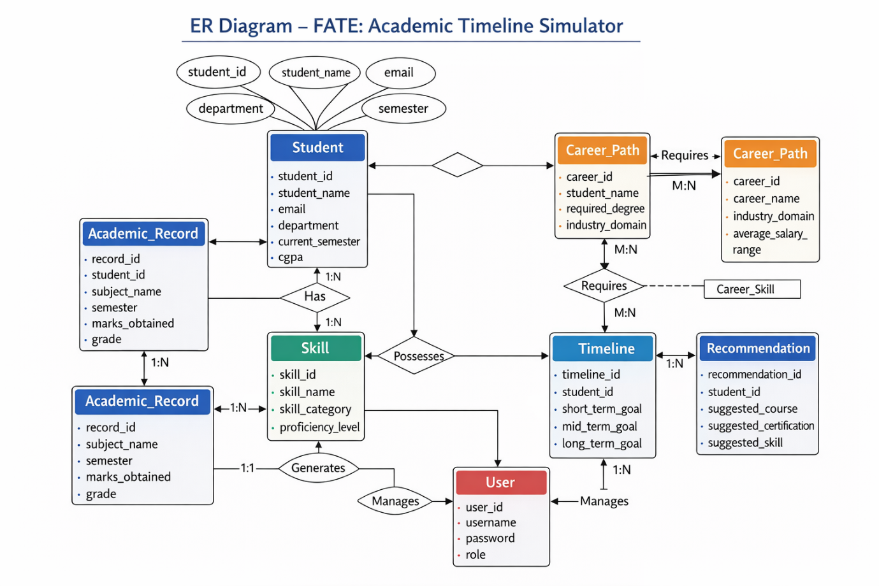

Screenshots of database
-- FATE - Alternate Academic Timeline Simulator
-- Database schema for MySQL

CREATE DATABASE IF NOT EXISTS fate_db;
USE fate_db;

-- ---------------------------------------------------------------------------
-- Reference / lookup tables
-- ---------------------------------------------------------------------------

CREATE TABLE courses (
id INT AUTO_INCREMENT PRIMARY KEY,
code VARCHAR(20) NOT NULL UNIQUE,
name VARCHAR(100) NOT NULL,
category ENUM('CORE', 'ELECTIVE') NOT NULL,
credits INT NOT NULL DEFAULT 3,
domain ENUM('CS', 'MATH', 'ENGINEERING', 'ARTS', 'BUSINESS', 'SCIENCE') NOT NULL,
INDEX idx_courses_domain (domain)
);

CREATE TABLE skills (
id INT AUTO_INCREMENT PRIMARY KEY,
name VARCHAR(80) NOT NULL,
category ENUM('TECHNICAL', 'SOFT', 'DOMAIN') NOT NULL,
INDEX idx_skills_category (category)
);

CREATE TABLE interests (
id INT AUTO_INCREMENT PRIMARY KEY,
name VARCHAR(80) NOT NULL
);

-- ---------------------------------------------------------------------------
-- Student and academic data
-- ---------------------------------------------------------------------------

CREATE TABLE students (
id INT AUTO_INCREMENT PRIMARY KEY,
name VARCHAR(100) NOT NULL,
email VARCHAR(120) NOT NULL,
created_at TIMESTAMP DEFAULT CURRENT_TIMESTAMP,
INDEX idx_students_email (email)
);

CREATE TABLE academic_snapshots (
id INT AUTO_INCREMENT PRIMARY KEY,
student_id INT NOT NULL,
semester_label VARCHAR(20) NOT NULL,
gpa DECIMAL(3,2) NOT NULL CHECK (gpa >= 0 AND gpa <= 4),
total_credits INT NOT NULL DEFAULT 0,
standing ENUM('DEANS_LIST', 'GOOD_STANDING', 'PROBATION', 'WARNING') NOT NULL DEFAULT 'GOOD_STANDING',
created_at TIMESTAMP DEFAULT CURRENT_TIMESTAMP,
UNIQUE KEY uk_snapshot_student_semester (student_id, semester_label),
FOREIGN KEY (student_id) REFERENCES students(id) ON DELETE CASCADE,
INDEX idx_snapshots_student_semester (student_id, semester_label)
);

CREATE TABLE enrollments (
id INT AUTO_INCREMENT PRIMARY KEY,
student_id INT NOT NULL,
course_id INT NOT NULL,
semester_label VARCHAR(20) NOT NULL,
grade VARCHAR(5) NOT NULL,
is_alternate BOOLEAN NOT NULL DEFAULT FALSE,
created_at TIMESTAMP DEFAULT CURRENT_TIMESTAMP,
FOREIGN KEY (student_id) REFERENCES students(id) ON DELETE CASCADE,
FOREIGN KEY (course_id) REFERENCES courses(id) ON DELETE CASCADE,
INDEX idx_enrollments_student (student_id),
INDEX idx_enrollments_semester (student_id, semester_label)
);

CREATE TABLE student_skills (
id INT AUTO_INCREMENT PRIMARY KEY,
student_id INT NOT NULL,
skill_id INT NOT NULL,
level TINYINT NOT NULL CHECK (level >= 1 AND level <= 5),
semester_acquired VARCHAR(20),
created_at TIMESTAMP DEFAULT CURRENT_TIMESTAMP,
UNIQUE KEY uk_student_skill (student_id, skill_id),
FOREIGN KEY (student_id) REFERENCES students(id) ON DELETE CASCADE,
FOREIGN KEY (skill_id) REFERENCES skills(id) ON DELETE CASCADE,
INDEX idx_student_skills_student (student_id)
);

CREATE TABLE student_interests (
id INT AUTO_INCREMENT PRIMARY KEY,
student_id INT NOT NULL,
interest_id INT NOT NULL,
strength TINYINT NOT NULL CHECK (strength >= 1 AND strength <= 5),
created_at TIMESTAMP DEFAULT CURRENT_TIMESTAMP,
UNIQUE KEY uk_student_interest (student_id, interest_id),
FOREIGN KEY (student_id) REFERENCES students(id) ON DELETE CASCADE,
FOREIGN KEY (interest_id) REFERENCES interests(id) ON DELETE CASCADE,
INDEX idx_student_interests_student (student_id)
);

-- ---------------------------------------------------------------------------
-- Decision points and simulations
-- ---------------------------------------------------------------------------

CREATE TABLE decision_points (
id INT AUTO_INCREMENT PRIMARY KEY,
student_id INT NOT NULL,
semester_label VARCHAR(20) NOT NULL,
decision_type VARCHAR(40) NOT NULL,
choice_detail TEXT,
impact_weight TINYINT NOT NULL DEFAULT 3 CHECK (impact_weight >= 1 AND impact_weight <= 5),
created_at TIMESTAMP DEFAULT CURRENT_TIMESTAMP,
FOREIGN KEY (student_id) REFERENCES students(id) ON DELETE CASCADE,
INDEX idx_decision_points_student (student_id)
);

CREATE TABLE simulations (
id INT AUTO_INCREMENT PRIMARY KEY,
student_id INT NOT NULL,
name VARCHAR(100) NOT NULL,
scenario_note TEXT,
created_at TIMESTAMP DEFAULT CURRENT_TIMESTAMP,
FOREIGN KEY (student_id) REFERENCES students(id) ON DELETE CASCADE,
INDEX idx_simulations_student (student_id)
);

CREATE TABLE simulation_decisions (
id INT AUTO_INCREMENT PRIMARY KEY,
simulation_id INT NOT NULL,
decision_point_id INT NOT NULL,
alternate_choice TEXT,
created_at TIMESTAMP DEFAULT CURRENT_TIMESTAMP,
UNIQUE KEY uk_sim_decision (simulation_id, decision_point_id),
FOREIGN KEY (simulation_id) REFERENCES simulations(id) ON DELETE CASCADE,
FOREIGN KEY (decision_point_id) REFERENCES decision_points(id) ON DELETE CASCADE,
INDEX idx_simulation_decisions_sim (simulation_id)
);

CREATE TABLE timeline_events (
id INT AUTO_INCREMENT PRIMARY KEY,
simulation_id INT NOT NULL,
sequence_order INT NOT NULL,
semester_label VARCHAR(20),
event_type VARCHAR(30) NOT NULL,
description TEXT,
impact_score TINYINT DEFAULT NULL,
created_at TIMESTAMP DEFAULT CURRENT_TIMESTAMP,
FOREIGN KEY (simulation_id) REFERENCES simulations(id) ON DELETE CASCADE,
INDEX idx_timeline_events_sim (simulation_id),
INDEX idx_timeline_events_order (simulation_id, sequence_order)
);

CREATE TABLE career_outcomes (
id INT AUTO_INCREMENT PRIMARY KEY,
simulation_id INT NOT NULL,
predicted_role VARCHAR(80) NOT NULL,
industry VARCHAR(60) NOT NULL,
confidence TINYINT NOT NULL CHECK (confidence >= 0 AND confidence <= 100),
reasoning_text TEXT,
created_at TIMESTAMP DEFAULT CURRENT_TIMESTAMP,
FOREIGN KEY (simulation_id) REFERENCES simulations(id) ON DELETE CASCADE,
INDEX idx_career_outcomes_sim (simulation_id)
);

-- ---------------------------------------------------------------------------
-- Seed data: sample courses, skills, interests
-- ---------------------------------------------------------------------------

INSERT INTO courses (code, name, category, credits, domain) VALUES
('CS101', 'Introduction to Programming', 'CORE', 4, 'CS'),
('CS201', 'Data Structures', 'CORE', 4, 'CS'),
('CS301', 'Algorithms', 'CORE', 3, 'CS'),
('MATH101', 'Calculus I', 'CORE', 4, 'MATH'),
('MATH201', 'Linear Algebra', 'CORE', 3, 'MATH'),
('ENG101', 'Engineering Fundamentals', 'CORE', 3, 'ENGINEERING'),
('BUSA101', 'Principles of Management', 'ELECTIVE', 3, 'BUSINESS'),
('BUSA201', 'Marketing', 'ELECTIVE', 3, 'BUSINESS'),
('SCI101', 'General Chemistry', 'CORE', 4, 'SCIENCE'),
('SCI201', 'Physics I', 'CORE', 4, 'SCIENCE'),
('ARTS101', 'Creative Writing', 'ELECTIVE', 3, 'ARTS'),
('CS401', 'Machine Learning', 'ELECTIVE', 3, 'CS'),
('MATH301', 'Probability & Statistics', 'CORE', 3, 'MATH');

INSERT INTO skills (name, category) VALUES
('Java Programming', 'TECHNICAL'),
('Python', 'TECHNICAL'),
('SQL', 'TECHNICAL'),
('Data Analysis', 'TECHNICAL'),
('Communication', 'SOFT'),
('Teamwork', 'SOFT'),
('Problem Solving', 'SOFT'),
('Research', 'DOMAIN'),
('Project Management', 'DOMAIN');

INSERT INTO interests (name) VALUES
('Machine Learning'),
('Software Development'),
('Data Science'),
('Research'),
('Writing'),
('Business Strategy'),
('Consulting'),
('Quantitative Finance');

Screenshots of Coding and Application:
( FATE –ACADEMIC TIMELINE SIMLUATOR)
Main.java
package fate;

import java.sql.SQLException;
import java.util.HashMap;
import java.util.List;
import java.util.Map;
import java.util.Objects;

import fate.dao.DecisionPointDAO;
import fate.db.DatabaseConnection;
import fate.model.DecisionPoint;
import fate.model.Student;
import fate.service.SimulationEngineService;
import fate.service.StudentService;
import fate.service.TimelineDisplayService;
import fate.util.ConsoleHelper;

/**
* FATE – Alternate Academic Timeline Simulator
* Console entry point: menu loop and service orchestration.
*/
public class Main {
private static Student currentStudent;
private static final StudentService studentService = new StudentService();
private static final SimulationEngineService simulationEngine = new SimulationEngineService(DatabaseConnection::getConnection);
private static final TimelineDisplayService timelineDisplay = new TimelineDisplayService();
private static final DecisionPointDAO decisionPointDAO = new DecisionPointDAO();

public static void main(String[] args) {
ConsoleHelper.println("FATE – Alternate Academic Timeline Simulator");
ConsoleHelper.println("--------------------------------------------");
runMenuLoop();
ConsoleHelper.close();
}

private static void runMenuLoop() {
while (true) {
printMainMenu();
int choice = ConsoleHelper.readInt("Choice: ", 1, 8);
switch (choice) {
case 1 -> {
studentService.runNewStudentFlow();
}
case 2 -> {
currentStudent = studentService.runSelectStudentFlow();
if (currentStudent != null) {
ConsoleHelper.println("Selected: " + currentStudent.getName() + " (ID " + currentStudent.getId() + ")");
}
}
case 3 -> {
studentService.runEnterAcademicDataFlow(currentStudent);
}
case 4 -> {
studentService.runSkillsAndInterestsFlow(currentStudent);
}
case 5 -> {
studentService.runAddDecisionPointsFlow(currentStudent);
}
case 6 -> {
runSimulationFlow();
}
case 7 -> {
viewTimelinesFlow();
}
case 8 -> {
ConsoleHelper.println("Goodbye.");
return;
}
}
}
}

private static void printMainMenu() {
ConsoleHelper.println("");
ConsoleHelper.println("--- Main Menu ---");
ConsoleHelper.println("1. New Student");
ConsoleHelper.println("2. Select Student");
ConsoleHelper.println("3. Enter Academic Data");
ConsoleHelper.println("4. Enter Skills and Interests");
ConsoleHelper.println("5. Add Decision Points");
ConsoleHelper.println("6. Run Simulation");
ConsoleHelper.println("7. View Timelines and Outcomes");
ConsoleHelper.println("8. Exit");
}

private static void runSimulationFlow() {
if (currentStudent == null) {
ConsoleHelper.println("Please select a student first (option 2).");
return;
}
ConsoleHelper.println("1. Base timeline (current data)");
ConsoleHelper.println("2. What-if scenario (override a decision)");
int sub = ConsoleHelper.readInt("Choice: ", 1, 2);
String name = ConsoleHelper.readLine("Simulation name: ");
if (name.isEmpty()) name = "Base timeline";
String note = ConsoleHelper.readLine("Scenario note (optional): ");

if (sub == 1) {
var sim = simulationEngine.runBaseSimulation(currentStudent.getId(), name, note);
if (sim != null) ConsoleHelper.println("Simulation created with ID: " + sim.getId());
} else {
try {
List<DecisionPoint> decisions = decisionPointDAO.findByStudentId(currentStudent.getId());
if (decisions.isEmpty()) {
ConsoleHelper.println("No decision points found. Add some first (option 5). Running as base.");
var sim = simulationEngine.runBaseSimulation(currentStudent.getId(), name, note);
if (sim != null) ConsoleHelper.println("Simulation created with ID: " + sim.getId());
return;
}
ConsoleHelper.println("Decision points:");
for (DecisionPoint dp : decisions) {
ConsoleHelper.println(" " + dp.getId() + ": " + dp.getSemesterLabel() + " - " + dp.getDecisionType() + " (" + Objects.toString(dp.getChoiceDetail(), "(no detail)") + ")");
}
int dpId = ConsoleHelper.readInt("Decision point ID to override (0 = none, run base): ", 0, 9999);
Map<Integer, String> overrides = new HashMap<>();
if (dpId != 0) {
String alt = ConsoleHelper.readLine("Alternate choice (what-if): ");
if (!alt.isEmpty()) overrides.put(dpId, alt);
}
var sim = simulationEngine.runSimulation(currentStudent.getId(), name, note, overrides);
if (sim != null) ConsoleHelper.println("Simulation created with ID: " + sim.getId());
} catch (SQLException e) {
ConsoleHelper.println("Database error: " + e.getMessage());
}
}
}

private static void viewTimelinesFlow() {
if (currentStudent == null) {
ConsoleHelper.println("Please select a student first (option 2).");
return;
}
timelineDisplay.listSimulationsForStudent(currentStudent.getId());
int simId = ConsoleHelper.readInt("Enter simulation ID to view (0 to back): ", 0, 99999);
if (simId != 0) {
timelineDisplay.showSimulationDetail(simId);
}
}
}

StumulationEngine.java
package fate.service;

import fate.dao.*;
import fate.model.*;
import fate.util.ConsoleHelper;

import java.sql.Connection;
import java.sql.SQLException;
import java.util.*;
import java.util.stream.Collectors;

/**
* Builds alternate academic timelines and career outcomes from student data using rule-based logic.
*/
public class SimulationEngineService {
private final DatabaseConnectionSupplier connectionSupplier;
private final AcademicSnapshotDAO snapshotDAO = new AcademicSnapshotDAO();
private final EnrollmentDAO enrollmentDAO = new EnrollmentDAO();
private final CourseDAO courseDAO = new CourseDAO();
private final StudentSkillDAO studentSkillDAO = new StudentSkillDAO();
private final SkillDAO skillDAO = new SkillDAO();
private final DecisionPointDAO decisionPointDAO = new DecisionPointDAO();
private final SimulationDAO simulationDAO = new SimulationDAO();
private final SimulationDecisionDAO simulationDecisionDAO = new SimulationDecisionDAO();
private final TimelineEventDAO timelineEventDAO = new TimelineEventDAO();
private final CareerOutcomeDAO careerOutcomeDAO = new CareerOutcomeDAO();
private final StudentInterestDAO studentInterestDAO = new StudentInterestDAO();
private final InterestDAO interestDAO = new InterestDAO();

public interface DatabaseConnectionSupplier {
Connection get() throws SQLException;
}

public SimulationEngineService(DatabaseConnectionSupplier supplier) {
this.connectionSupplier = supplier;
}

/**
* Runs a base timeline simulation (no overrides) and persists simulation, timeline_events, career_outcomes.
*/
public Simulation runBaseSimulation(int studentId, String simulationName, String scenarioNote) {
return runSimulation(studentId, simulationName, scenarioNote, null);
}

/**
* Runs a what-if simulation with optional decision overrides. Map: decisionPointId -> alternateChoice.
*/
public Simulation runSimulation(int studentId, String simulationName, String scenarioNote, Map<Integer, String> alternateDecisions) {
try (Connection conn = connectionSupplier.get()) {
conn.setAutoCommit(false);
try {
Simulation sim = new Simulation();
sim.setStudentId(studentId);
sim.setName(simulationName != null && !simulationName.isEmpty() ? simulationName : "Simulation");
sim.setScenarioNote(scenarioNote);
simulationDAO.insert(conn, sim);
int simId = sim.getId();

if (alternateDecisions != null && !alternateDecisions.isEmpty()) {
for (Map.Entry<Integer, String> e : alternateDecisions.entrySet()) {
simulationDecisionDAO.insert(conn, simId, e.getKey(), e.getValue());
}
}

List<TimelineEvent> events = buildTimelineEvents(studentId, simId, alternateDecisions != null ? alternateDecisions : Map.of());
for (TimelineEvent ev : events) {
timelineEventDAO.insert(conn, ev);
}

List<CareerOutcome> outcomes = buildCareerOutcomes(studentId, simId);
for (CareerOutcome co : outcomes) {
careerOutcomeDAO.insert(conn, co);
}

conn.commit();
return sim;
} catch (Exception e) {
conn.rollback();
throw e;
}
} catch (Exception e) {
ConsoleHelper.println("Error: " + (e.getMessage() != null ? e.getMessage() : e.getClass().getSimpleName()));
return null;
}
}

private List<String> orderedSemesters(int studentId) throws SQLException {
Set<String> semesters = new HashSet<>();
for (AcademicSnapshot a : snapshotDAO.findByStudentId(studentId)) {
semesters.add(a.getSemesterLabel());
}
for (Enrollment e : enrollmentDAO.findByStudentIdAndAlternate(studentId, false)) {
semesters.add(e.getSemesterLabel());
}
List<String> list = new ArrayList<>(semesters);
Collections.sort(list);
return list;
}

private List<TimelineEvent> buildTimelineEvents(int studentId, int simulationId, Map<Integer, String> alternateChoices) throws SQLException {
List<TimelineEvent> events = new ArrayList<>();
List<String> semesters = orderedSemesters(studentId);
if (semesters.isEmpty()) {
TimelineEvent ev = new TimelineEvent();
ev.setSimulationId(simulationId);
ev.setSequenceOrder(1);
ev.setSemesterLabel(null);
ev.setEventType("MILESTONE");
ev.setDescription("No academic data yet. Add semesters and enrollments to see a timeline.");
ev.setImpactScore(null);
events.add(ev);
return events;
}

Map<String, AcademicSnapshot> snapshotBySemester = new HashMap<>();
for (AcademicSnapshot a : snapshotDAO.findByStudentId(studentId)) {
snapshotBySemester.put(a.getSemesterLabel(), a);
}
List<Enrollment> enrollments = enrollmentDAO.findByStudentIdAndAlternate(studentId, false);
Map<String, List<Enrollment>> enrollmentsBySemester = enrollments.stream().collect(Collectors.groupingBy(Enrollment::getSemesterLabel));
List<StudentSkillDAO.Row> skillRows = studentSkillDAO.findByStudentId(studentId);
Map<String, List<StudentSkillDAO.Row>> skillsBySemester = new HashMap<>();
for (StudentSkillDAO.Row r : skillRows) {
String sem = r.getSemesterAcquired() != null ? r.getSemesterAcquired() : "";
skillsBySemester.computeIfAbsent(sem, k -> new ArrayList<>()).add(r);
}
List<DecisionPoint> decisions = decisionPointDAO.findByStudentId(studentId);
Map<String, List<DecisionPoint>> decisionsBySemester = decisions.stream().collect(Collectors.groupingBy(DecisionPoint::getSemesterLabel));

int order = 0;
for (String sem : semesters) {
AcademicSnapshot snap = snapshotBySemester.get(sem);
if (snap != null && "DEANS_LIST".equals(snap.getStanding())) {
TimelineEvent ev = new TimelineEvent();
ev.setSimulationId(simulationId);
ev.setSequenceOrder(++order);
ev.setSemesterLabel(sem);
ev.setEventType("MILESTONE");
ev.setDescription("Dean's List - " + sem);
ev.setImpactScore(4);
events.add(ev);
}

for (Enrollment enr : enrollmentsBySemester.getOrDefault(sem, List.of())) {
Course c = courseDAO.findById(enr.getCourseId());
String courseName = c != null ? c.getCode() + " " + c.getName() : "Course " + enr.getCourseId();
TimelineEvent ev = new TimelineEvent();
ev.setSimulationId(simulationId);
ev.setSequenceOrder(++order);
ev.setSemesterLabel(sem);
ev.setEventType("COURSE_TAKEN");
ev.setDescription(courseName + " - Grade: " + enr.getGrade());
ev.setImpactScore(3);
events.add(ev);
}

for (StudentSkillDAO.Row r : skillsBySemester.getOrDefault(sem, List.of())) {
Skill sk = skillDAO.findById(r.getSkillId());
String skillName = sk != null ? sk.getName() : "Skill " + r.getSkillId();
TimelineEvent ev = new TimelineEvent();
ev.setSimulationId(simulationId);
ev.setSequenceOrder(++order);
ev.setSemesterLabel(sem);
ev.setEventType("SKILL_GAINED");
ev.setDescription(skillName + " (level " + r.getLevel() + ")");
ev.setImpactScore(r.getLevel());
events.add(ev);
}

for (DecisionPoint dp : decisionsBySemester.getOrDefault(sem, List.of())) {
String choice = alternateChoices.getOrDefault(dp.getId(), dp.getChoiceDetail());
if (choice == null) choice = dp.getChoiceDetail();
TimelineEvent ev = new TimelineEvent();
ev.setSimulationId(simulationId);
ev.setSequenceOrder(++order);
ev.setSemesterLabel(sem);
ev.setEventType("DECISION_MADE");
ev.setDescription(dp.getDecisionType() + ": " + (choice != null ? choice : "(no detail)"));
ev.setImpactScore(dp.getImpactWeight());
events.add(ev);
}
}
// Skills with no semester (null or empty) appear at end of timeline
for (StudentSkillDAO.Row r : skillsBySemester.getOrDefault("", List.of())) {
Skill sk = skillDAO.findById(r.getSkillId());
String skillName = sk != null ? sk.getName() : "Skill " + r.getSkillId();
TimelineEvent ev = new TimelineEvent();
ev.setSimulationId(simulationId);
ev.setSequenceOrder(++order);
ev.setSemesterLabel(null);
ev.setEventType("SKILL_GAINED");
ev.setDescription(skillName + " (level " + r.getLevel() + ") - no semester");
ev.setImpactScore(r.getLevel());
events.add(ev);
}
return events;
}

private List<CareerOutcome> buildCareerOutcomes(int studentId, int simulationId) throws SQLException {
List<CareerOutcome> outcomes = new ArrayList<>();
List<AcademicSnapshot> snapshots = snapshotDAO.findByStudentId(studentId);
List<Enrollment> enrollments = enrollmentDAO.findByStudentIdAndAlternate(studentId, false);
List<StudentSkillDAO.Row> skillRows = studentSkillDAO.findByStudentId(studentId);
List<StudentInterestDAO.Row> interestRows = studentInterestDAO.findByStudentId(studentId);

double avgGpa = snapshots.isEmpty() ? 0 : snapshots.stream().mapToDouble(AcademicSnapshot::getGpa).average().orElse(0);
Map<String, Long> domainCount = new HashMap<>();
int techCredits = 0;
for (Enrollment e : enrollments) {
Course c = courseDAO.findById(e.getCourseId());
if (c != null) {
domainCount.merge(c.getDomain(), 1L, Long::sum);
if ("CS".equals(c.getDomain()) || "ENGINEERING".equals(c.getDomain())) techCredits += c.getCredits();
}
}
long csCount = domainCount.getOrDefault("CS", 0L);
long mathCount = domainCount.getOrDefault("MATH", 0L);
long scienceCount = domainCount.getOrDefault("SCIENCE", 0L);
long businessCount = domainCount.getOrDefault("BUSINESS", 0L);

int technicalSkillLevel = 0;
int softSkillLevel = 0;
for (StudentSkillDAO.Row r : skillRows) {
Skill s = skillDAO.findById(r.getSkillId());
if (s != null) {
if ("TECHNICAL".equals(s.getCategory())) technicalSkillLevel += r.getLevel();
if ("SOFT".equals(s.getCategory())) softSkillLevel += r.getLevel();
}
}

boolean hasResearchInterest = false;
boolean hasDataInterest = false;
boolean hasBusinessInterest = false;
for (StudentInterestDAO.Row r : interestRows) {
Interest i = interestDAO.findById(r.getInterestId());
if (i != null) {
String name = i.getName().toLowerCase();
if (name.contains("research")) hasResearchInterest = true;
if (name.contains("data") || name.contains("machine learning")) hasDataInterest = true;
if (name.contains("business") || name.contains("consulting")) hasBusinessInterest = true;
}
}

// Rule 1: Strong CS/Eng + technical skills + good GPA -> Tech roles
if (avgGpa >= 3.0 && (csCount >= 2 || techCredits >= 12) && technicalSkillLevel >= 3) {
CareerOutcome co = new CareerOutcome();
co.setSimulationId(simulationId);
co.setPredictedRole(hasDataInterest ? "Data Analyst" : "Software Engineer");
co.setIndustry("Technology");
co.setConfidence(Math.min(90, 60 + (int) (avgGpa * 5) + Math.min(20, technicalSkillLevel * 3)));
co.setReasoningText("Strong technical coursework and skills with solid GPA suggest strong fit for tech roles.");
outcomes.add(co);
}

// Rule 2: MATH + SCIENCE + research interest -> Research
if ((mathCount >= 1 || scienceCount >= 1) && hasResearchInterest && avgGpa >= 3.2) {
CareerOutcome co = new CareerOutcome();
co.setSimulationId(simulationId);
co.setPredictedRole("Research Scientist / Quant");
co.setIndustry("Academia / Research / Finance");
co.setConfidence(Math.min(85, 50 + (int) (avgGpa * 8)));
co.setReasoningText("Math/Science background with research interest supports research or quantitative roles.");
outcomes.add(co);
}

// Rule 3: BUSINESS + soft skills
if (businessCount >= 1 && softSkillLevel >= 3) {
CareerOutcome co = new CareerOutcome();
co.setSimulationId(simulationId);
co.setPredictedRole(hasBusinessInterest ? "Consultant" : "Business Analyst");
co.setIndustry("Consulting / Business");
co.setConfidence(Math.min(80, 45 + softSkillLevel * 8 + (int) (avgGpa * 5)));
co.setReasoningText("Business coursework and soft skills align with analyst or consulting paths.");
outcomes.add(co);
}

// Default: diverse / further education
if (outcomes.isEmpty()) {
CareerOutcome co = new CareerOutcome();
co.setSimulationId(simulationId);
co.setPredictedRole("Diverse roles / Further education");
co.setIndustry("Various");
co.setConfidence(Math.min(70, 30 + (int) (avgGpa * 10)));
co.setReasoningText("Broad profile. Consider adding more courses or skills to strengthen a specific path; further education can help specialize.");
outcomes.add(co);
}

return outcomes;
}
}

StudentService.java

package fate.service;

import fate.dao.*;
import fate.model.*;
import fate.util.ConsoleHelper;

import java.sql.SQLException;
import java.util.List;

/**
* Orchestrates student creation, selection, and data entry (academic, skills, interests, decisions).
*/
public class StudentService {
private final StudentDAO studentDAO = new StudentDAO();
private final AcademicSnapshotDAO snapshotDAO = new AcademicSnapshotDAO();
private final CourseDAO courseDAO = new CourseDAO();
private final EnrollmentDAO enrollmentDAO = new EnrollmentDAO();
private final SkillDAO skillDAO = new SkillDAO();
private final InterestDAO interestDAO = new InterestDAO();
private final StudentSkillDAO studentSkillDAO = new StudentSkillDAO();
private final StudentInterestDAO studentInterestDAO = new StudentInterestDAO();
private final DecisionPointDAO decisionPointDAO = new DecisionPointDAO();

public Student createStudent(String name, String email) {
Student s = new Student();
s.setName(name);
s.setEmail(email);
try {
studentDAO.insert(s);
return s;
} catch (SQLException e) {
ConsoleHelper.println("Database error: " + e.getMessage());
return null;
}
}

public List<Student> listAllStudents() {
try {
return studentDAO.findAll();
} catch (SQLException e) {
ConsoleHelper.println("Database error: " + e.getMessage());
return List.of();
}
}

public Student getStudentById(int id) {
try {
return studentDAO.findById(id);
} catch (SQLException e) {
ConsoleHelper.println("Database error: " + e.getMessage());
return null;
}
}

public void runNewStudentFlow() {
String name = ConsoleHelper.readLine("Enter student name: ");
if (name.isEmpty()) {
ConsoleHelper.println("Name cannot be empty.");
return;
}
String email = ConsoleHelper.readLine("Enter email: ");
if (email.isEmpty()) email = name.replaceAll("\\s+", "") + "@example.com";
Student s = createStudent(name, email);
if (s != null) ConsoleHelper.println("Student created with ID: " + s.getId());
}

public Student runSelectStudentFlow() {
List<Student> list = listAllStudents();
if (list.isEmpty()) {
ConsoleHelper.println("No students found. Create one first.");
return null;
}
ConsoleHelper.println("--- Students ---");
for (Student s : list) {
ConsoleHelper.println(" " + s.getId() + ": " + s.getName() + " (" + s.getEmail() + ")");
}
int id = ConsoleHelper.readInt("Enter student ID: ", 1, Integer.MAX_VALUE);
Student s = getStudentById(id);
if (s == null) ConsoleHelper.println("Student not found.");
return s;
}

public void runEnterAcademicDataFlow(Student student) {
if (student == null) {
ConsoleHelper.println("Please select a student first.");
return;
}
ConsoleHelper.println("--- Academic snapshot (semester) ---");
String semester = ConsoleHelper.readLine("Semester label (e.g. Y1S1, Y2S2): ");
if (semester.isEmpty()) return;
double gpa = ConsoleHelper.readDouble("GPA (0-4): ", 0, 4);
int credits = ConsoleHelper.readInt("Total credits earned so far: ", 0, 500);
ConsoleHelper.println("Standing: 1=DEANS_LIST 2=GOOD_STANDING 3=PROBATION 4=WARNING");
int standingChoice = ConsoleHelper.readInt("Choice (1-4): ", 1, 4);
String standing = new String[]{"DEANS_LIST", "GOOD_STANDING", "PROBATION", "WARNING"}[standingChoice - 1];

AcademicSnapshot a = new AcademicSnapshot();
a.setStudentId(student.getId());
a.setSemesterLabel(semester);
a.setGpa(gpa);
a.setTotalCredits(credits);
a.setStanding(standing);
try {
snapshotDAO.insert(a);
ConsoleHelper.println("Academic snapshot saved.");
} catch (SQLException e) {
ConsoleHelper.println("Database error: " + e.getMessage());
}

ConsoleHelper.println("Add course enrollments for this semester? 1=Yes 0=No");
int addEnroll = ConsoleHelper.readInt("Choice: ", 0, 1);
if (addEnroll == 1) {
List<Course> courses = listCourses();
if (courses.isEmpty()) return;
for (Course c : courses) {
ConsoleHelper.println(" " + c.getId() + ": " + c.getCode() + " - " + c.getName());
}
ConsoleHelper.println("Enter course ID to enroll (0 to stop): ");
while (true) {
int cid = ConsoleHelper.readInt("Course ID: ", 0, 9999);
if (cid == 0) break;
Course course = null;
try {
course = courseDAO.findById(cid);
} catch (SQLException ex) {
ConsoleHelper.println("Error looking up course: " + ex.getMessage());
}
if (course == null) {
ConsoleHelper.println("Course ID not found. Use an ID from the list above.");
ConsoleHelper.println("Add another? 1=Yes 0=No");
if (ConsoleHelper.readInt("Choice: ", 0, 1) == 0) break;
continue;
}
String grade = ConsoleHelper.readLine("Grade (e.g. A, B+, 3.5): ");
if (grade.isEmpty()) grade = "B";
Enrollment e = new Enrollment();
e.setStudentId(student.getId());
e.setCourseId(cid);
e.setSemesterLabel(semester);
e.setGrade(grade);
e.setAlternate(false);
try {
enrollmentDAO.insert(e);
ConsoleHelper.println("Enrollment added.");
} catch (SQLException ex) {
ConsoleHelper.println("Error: " + ex.getMessage());
}
ConsoleHelper.println("Add another? 1=Yes 0=No");
if (ConsoleHelper.readInt("Choice: ", 0, 1) == 0) break;
}
}
}

public List<Course> listCourses() {
try {
return courseDAO.findAll();
} catch (SQLException e) {
ConsoleHelper.println("Database error: " + e.getMessage());
return List.of();
}
}

public void runSkillsAndInterestsFlow(Student student) {
if (student == null) {
ConsoleHelper.println("Please select a student first.");
return;
}
try {
List<Skill> skills = skillDAO.findAll();
ConsoleHelper.println("--- Skills (level 1-5) ---");
for (Skill s : skills) ConsoleHelper.println(" " + s.getId() + ": " + s.getName());
int sid = ConsoleHelper.readInt("Skill ID to add (0 to skip): ", 0, 9999);
if (sid != 0) {
try {
if (skillDAO.findById(sid) == null) {
ConsoleHelper.println("Skill ID not found. Use an ID from the list above.");
} else {
int level = ConsoleHelper.readInt("Level (1-5): ", 1, 5);
String sem = ConsoleHelper.readLine("Semester acquired (optional): ");
studentSkillDAO.insert(student.getId(), sid, level, sem.isEmpty() ? null : sem);
ConsoleHelper.println("Skill added.");
}
} catch (SQLException ex) {
ConsoleHelper.println("Error: " + ex.getMessage());
}
}

List<Interest> interests = interestDAO.findAll();
ConsoleHelper.println("--- Interests (strength 1-5) ---");
for (Interest i : interests) ConsoleHelper.println(" " + i.getId() + ": " + i.getName());
int iid = ConsoleHelper.readInt("Interest ID to add (0 to skip): ", 0, 9999);
if (iid != 0) {
try {
if (interestDAO.findById(iid) == null) {
ConsoleHelper.println("Interest ID not found. Use an ID from the list above.");
} else {
int strength = ConsoleHelper.readInt("Strength (1-5): ", 1, 5);
studentInterestDAO.insert(student.getId(), iid, strength);
ConsoleHelper.println("Interest added.");
}
} catch (SQLException ex) {
ConsoleHelper.println("Error: " + ex.getMessage());
}
}
} catch (SQLException e) {
ConsoleHelper.println("Database error: " + e.getMessage());
}
}

public void runAddDecisionPointsFlow(Student student) {
if (student == null) {
ConsoleHelper.println("Please select a student first.");
return;
}
String semester = ConsoleHelper.readLine("Semester label for this decision: ");
if (semester.isEmpty()) return;
ConsoleHelper.println("Decision type: 1=SPECIALIZATION_SWITCH 2=SKILL_FOCUS 3=COURSE_DROP 4=EXTRA_COURSE 5=GAP_SEMESTER 6=OTHER");
int typeChoice = ConsoleHelper.readInt("Choice (1-6): ", 1, 6);
String[] types = {"SPECIALIZATION_SWITCH", "SKILL_FOCUS", "COURSE_DROP", "EXTRA_COURSE", "GAP_SEMESTER", "OTHER"};
String decisionType = types[typeChoice - 1];
String detail = ConsoleHelper.readLine("Choice detail (what you decided): ");
int impact = ConsoleHelper.readInt("Impact weight (1-5): ", 1, 5);

DecisionPoint d = new DecisionPoint();
d.setStudentId(student.getId());
d.setSemesterLabel(semester);
d.setDecisionType(decisionType);
d.setChoiceDetail(detail);
d.setImpactWeight(impact);
try {
decisionPointDAO.insert(d);
ConsoleHelper.println("Decision point saved.");
} catch (SQLException e) {
ConsoleHelper.println("Database error: " + e.getMessage());
}
}
}

TimeLineDisplay.java

package fate.service;

import fate.dao.CareerOutcomeDAO;
import fate.dao.SimulationDAO;
import fate.dao.TimelineEventDAO;
import fate.model.CareerOutcome;
import fate.model.Simulation;
import fate.model.TimelineEvent;
import fate.util.ConsoleHelper;

import java.sql.SQLException;
import java.util.List;

/**
* Formats and prints timelines and career outcomes to the console.
*/
public class TimelineDisplayService {
private final SimulationDAO simulationDAO = new SimulationDAO();
private final TimelineEventDAO timelineEventDAO = new TimelineEventDAO();
private final CareerOutcomeDAO careerOutcomeDAO = new CareerOutcomeDAO();

public void listSimulationsForStudent(int studentId) {
try {
List<Simulation> list = simulationDAO.findByStudentId(studentId);
if (list.isEmpty()) {
ConsoleHelper.println("No simulations found for this student. Run a simulation first.");
return;
}
ConsoleHelper.println("--- Your simulations ---");
for (Simulation s : list) {
ConsoleHelper.println(" " + s.getId() + ": " + s.getName() + " (" + (s.getScenarioNote() != null ? s.getScenarioNote() : "") + ")");
}
} catch (SQLException e) {
ConsoleHelper.println("Database error: " + e.getMessage());
}
}

public void showSimulationDetail(int simulationId) {
try {
Simulation sim = simulationDAO.findById(simulationId);
if (sim == null) {
ConsoleHelper.println("Simulation not found.");
return;
}
ConsoleHelper.println("\n=== " + sim.getName() + " ===");
if (sim.getScenarioNote() != null && !sim.getScenarioNote().isEmpty()) {
ConsoleHelper.println("Scenario: " + sim.getScenarioNote());
}

List<TimelineEvent> events = timelineEventDAO.findBySimulationId(simulationId);
ConsoleHelper.println("\n--- Timeline ---");
if (events.isEmpty()) {
ConsoleHelper.println(" (No events)");
} else {
for (TimelineEvent e : events) {
String sem = e.getSemesterLabel() != null ? " [" + e.getSemesterLabel() + "]" : "";
ConsoleHelper.println(" " + e.getSequenceOrder() + "." + sem + " " + e.getEventType() + ": " + e.getDescription());
}
}

List<CareerOutcome> outcomes = careerOutcomeDAO.findBySimulationId(simulationId);
ConsoleHelper.println("\n--- Career outcomes ---");
if (outcomes.isEmpty()) {
ConsoleHelper.println(" (None)");
} else {
for (CareerOutcome c : outcomes) {
ConsoleHelper.println(" * " + c.getPredictedRole() + " (" + c.getIndustry() + ") - Confidence: " + c.getConfidence() + "%");
if (c.getReasoningText() != null && !c.getReasoningText().isEmpty()) {
ConsoleHelper.println(" " + c.getReasoningText());
}
}
}
ConsoleHelper.println("");
} catch (SQLException e) {
ConsoleHelper.println("Database error: " + e.getMessage());
}
}
}

OUTPUT :

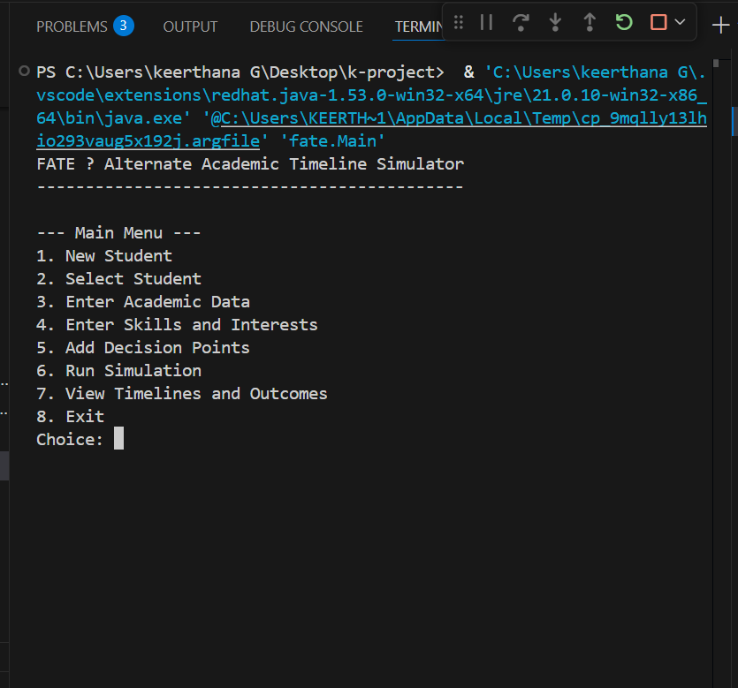
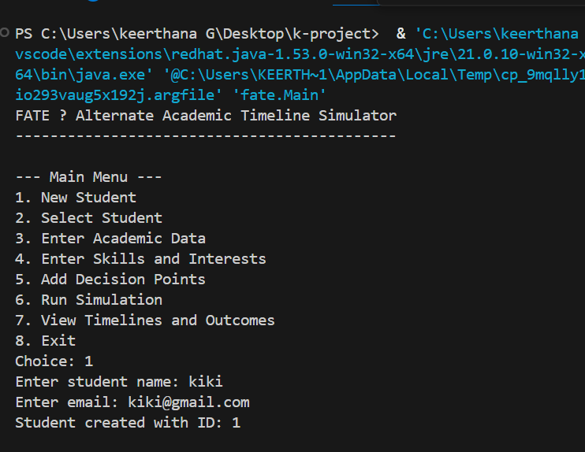
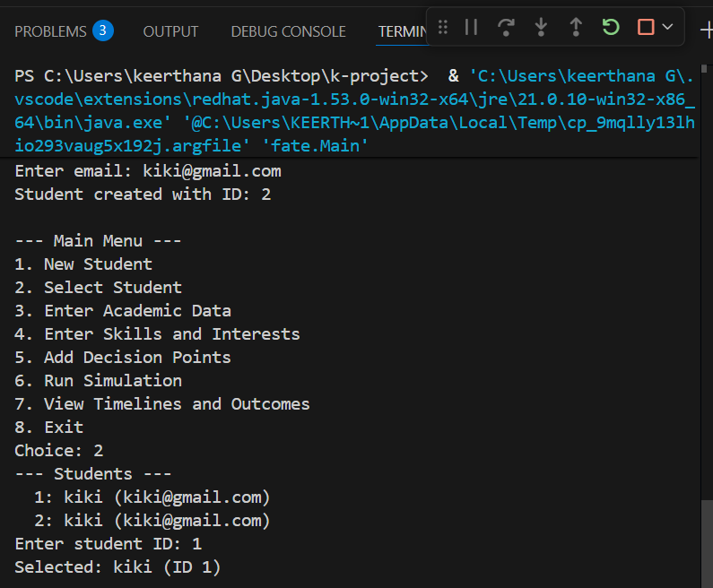
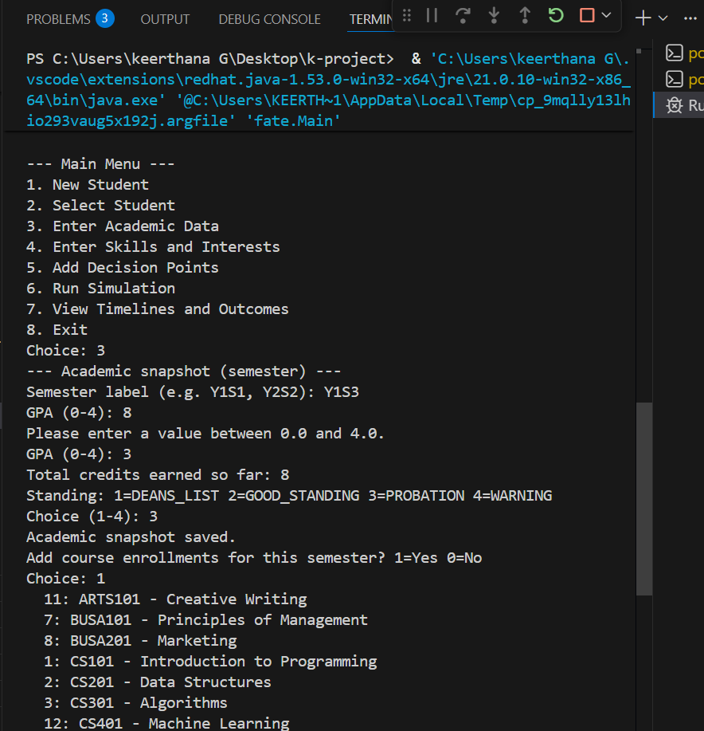
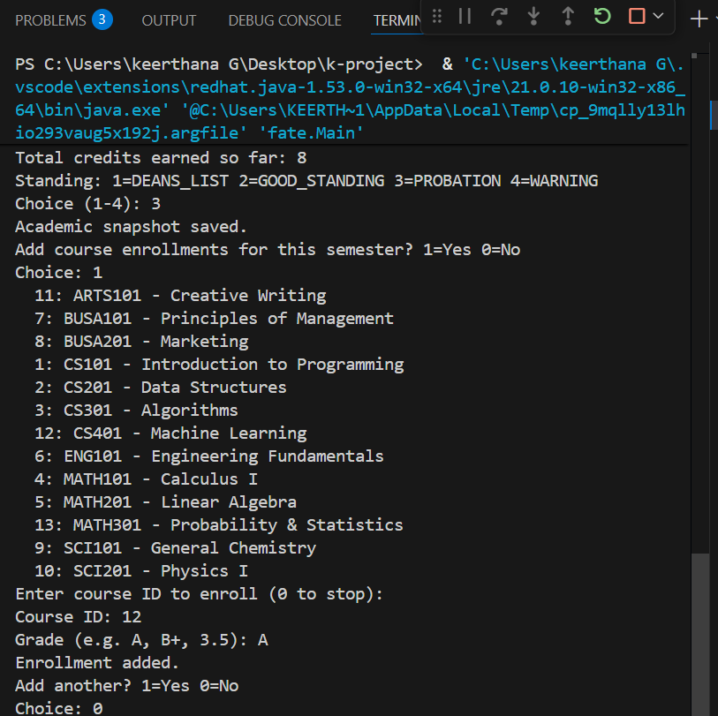

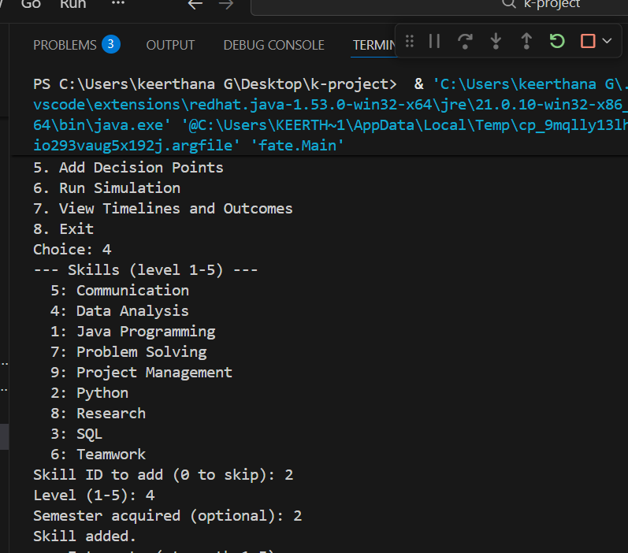
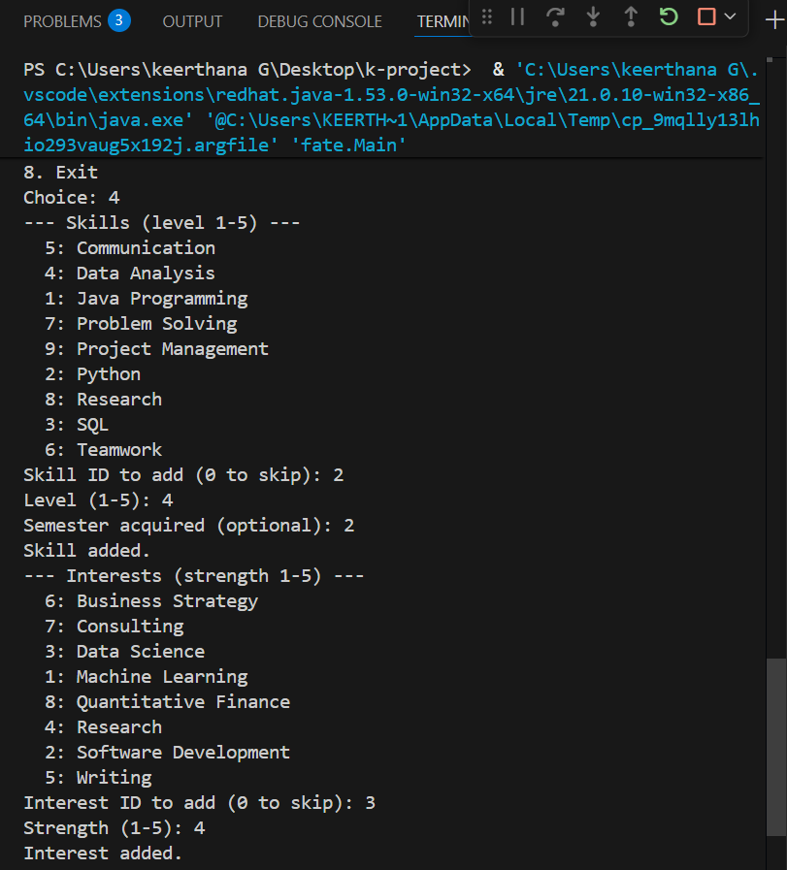

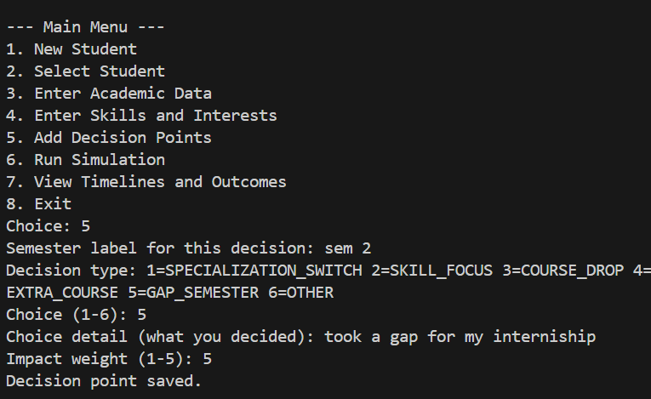
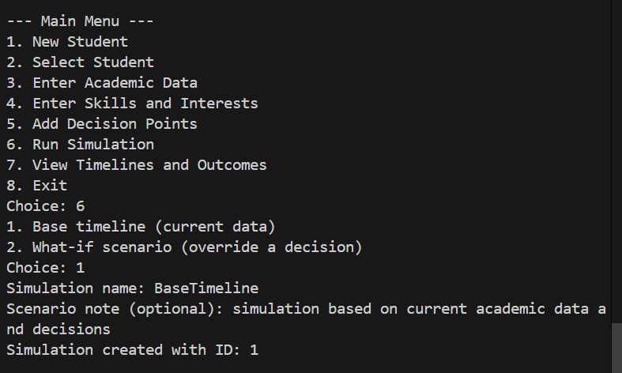

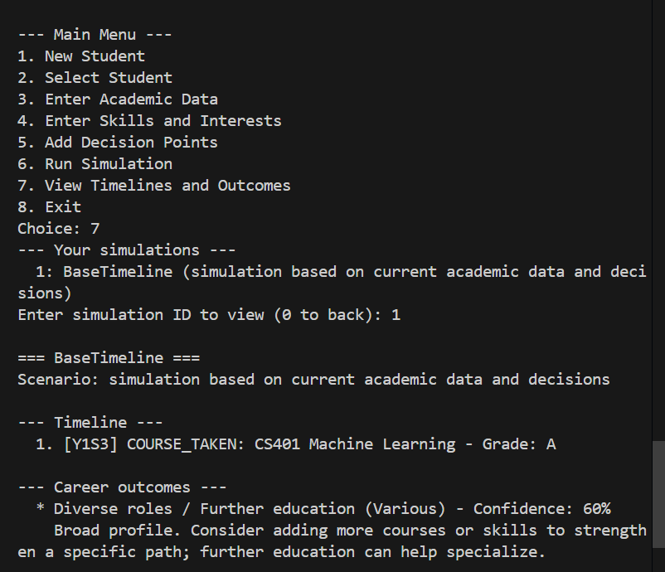
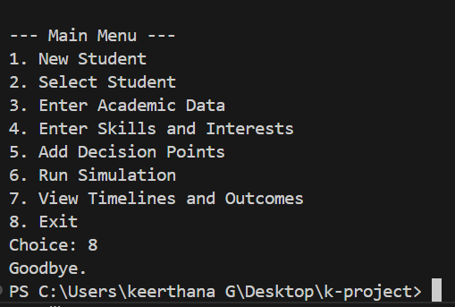

CONCLUSION

The FATE – Academic Timeline Simulator project was developed to help students plan and visualize their academic and career journey in a structured and meaningful way. The system provides a platform where students can track their academic records, identify important skills, explore possible career paths, and create a timeline of short-term and long-term goals.
The project demonstrates how technology can support students in making better academic and career decisions. By analyzing student performance, skills, and interests, the system can generate useful recommendations that guide students toward suitable courses, certifications, and career opportunities. This helps students understand their progress and prepare themselves for future challenges.
Another important contribution of this project is that it promotes goal-based learning. Instead of studying without direction, students can clearly see what steps are needed to achieve their academic and professional goals. This structured approach motivates students to stay focused, improve their performance, and continuously develop their skills.
In addition, the system improves self-assessment and planning ability among students. By reviewing their academic timeline, students can identify strengths, weaknesses, and areas that require improvement. This enables them to make informed decisions regarding higher education and career opportunities.
Overall, the FATE system provides a simple, interactive, and student-friendly platform that bridges the gap between academic performance and career planning. It highlights how digital tools can play an important role in guiding students toward a more organized and successful future.

